Question number 25

Prepared for: BEEE Lab evaluation

Prepared by: ISHIKA KANSAL

21 October 2019

UID: 19BCS4584

# Executive Summary

## Objective

|  |
| --- |
| 25.design asystem for door at home such that whenever a door is opened a light turns on for 1000ms if it is day and 2000if it is night. |

## Solutions

## Concept used

The concepts used by me to do this experiment are:-

• The arduino board can supply a power of 5v as digital output signals through the 14 pins (namely 0-13) present in it as digital input or output pins.

• The GND pin of the arduino board acts as ground.

• In the bread board present in the above circuit diagram the two rows present at the top and bottom each, are connected with each other in series and the columns present in between are connected in a set of 5 each. The connection pattern is shown below: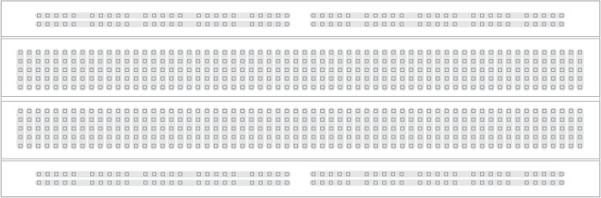

• In series crcuit voltage gets divided and in parallel circuit  current gets divided.

• Kirchoff’s current law:-Total current flowing through a junction is equal to current flowing out of the junction.

• Ohm’s Law:-Ohm’s law states that the current through a conductor is directly proportional to the voltage across the two points provided that the physical conditions such as temperature remains constant.

                       V=IR

**Learning and Observation:-**

**Learning:-**

* IamlearninghowtouseLDRinthecircuit
* Iamlearningtoutiliseinternettofullextent
* Ialsousedpushbuttoninthecircuitandunderstooditsfunctioning

**Observations:-**

Whenthereisdarknessandeitherofthepushbuttonispressedthenredledglowsandifbotharepressedthengreenledglows 

**Problems and Troubleshooting:-**

* TheLEDswerenotworkingproperlysoIhadtoreplacethemwithnewones
* TheendsofthewirewerenotgettinginsertedproperlyintheholesofthebreadboardsoIhadtomaketheendsofthewirestraightfirstusingasandpaper 
* Thearduinoboardwasnotworking ThecableconnectingthearduinoboardwaslooseatoneendsoIhadtoreplacethecablewithanotherone
* TherequiredoutcomewasnotgettingcreatedbecauseofsomeerrorinthecodesoIhadtochangethecodeasperrequirement

**Precautions:-**

The precautions that we need to keep in mind while performing this experiment are:-

• The wires are inserted properly and tightly at the required points so that the circuit doesn’t get short.

• The two pins of the LED should be connected at their appropriate point that is the positive point should be connected with the p pin and the negative point should be connected with the negative pin.

* We should take care that the circuit is closed .
* Connection to resistance to ground should be checked.